'Programmer: Samantha Naini
'Date: 3/5/2012
'Exercise: 4-2-21, pg. 126
'Program Purpose: To determine how much to tip the server at a restaurant.

Option Strict On
Option Explicit On

Public Class frmTip

Private Sub btnCompute_Click(ByVal sender As System.Object, ByVal e As System.EventArgs) Handles btnCompute.Click

Dim cost, tip As Double
cost = CDbl(InputBox("Enter cost of meal:"))
tip = cost * 0.15
If tip < 1 Then
tip = 1
End If

txtOutput.Text = "Leave " & FormatCurrency(tip) & " for the tip."
End Sub

Private Sub btnClear_Click(ByVal sender As System.Object, ByVal e As System.EventArgs) Handles btnClear.Click
txtOutput.Clear()
End Sub

Private Sub btnEnd_Click(ByVal sender As System.Object, ByVal e As System.EventArgs) Handles btnEnd.Click
Me.Close()
End Sub

End Class
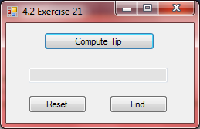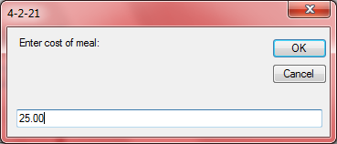
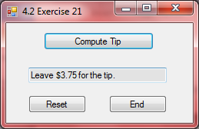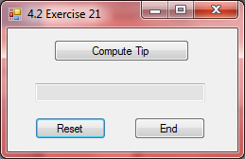←Reset button

'Programmer: Samantha Naini
'Date: 3/5/2012
'Exercise: 4-2-24, pg.126
'Program Purpose: To display the cost of a number of copies when a copy center charges
'5 cents/copy for the first 100 copies, and 3 cents/copy for each ADDITIONAL copy.

Option Strict On
Option Explicit On

Public Class frmCopyCenter

Private Sub btnCompute_Click(ByVal sender As System.Object, ByVal e As System.EventArgs) Handles btnCompute.Click

Dim NumOfCopies, Cost As Double

NumOfCopies = CDbl(InputBox("Number of copies:"))

If NumOfCopies < 100 Then
Cost = 0.05 * NumOfCopies 'copies at 5 cents each

ElseIf NumOfCopies > 100 Then

Cost = 0.03 * (NumOfCopies - 100) + 5 'copies at 3 cents each; the 5 is five dollars for 100 copies at 5 cents each

End If

txtOutput.Text = "The cost is " & FormatCurrency(Cost) & "."

End Sub

Private Sub btnClear_Click(ByVal sender As System.Object, ByVal e As System.EventArgs) Handles btnClear.Click
txtOutput.Clear()
End Sub

Private Sub btnEnd_Click(ByVal sender As System.Object, ByVal e As System.EventArgs) Handles btnEnd.Click
Me.Close()
End Sub

End Class
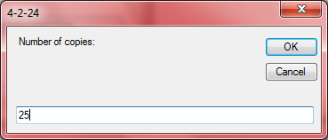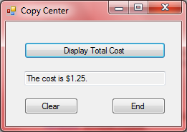
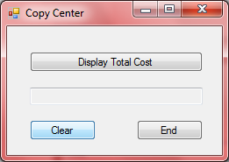←clear button
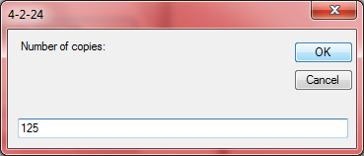
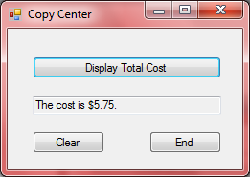
'Programmer: Samantha Naini
'Date: 3/5/2012
'Exercise: 4-2-26 pg. 127
'Program Purpose: Create a program with the button "Quit" that requests if the person really wants to quit or not by answering yes or no.

Option Strict On
Option Explicit On

Public Class frmQuitter

Private Sub btnQuit_Click(ByVal sender As System.Object, ByVal e As System.EventArgs) Handles btnQuit.Click

Dim AreYouSure As String

If MsgBox("Are you sure you want to quit?", MsgBoxStyle.YesNoCancel) = MsgBoxResult.Yes Then

MessageBox.Show("Have a nice Day!", "Quit")
Me.Close()

End If

End Sub
End Class

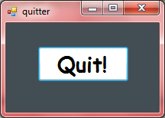
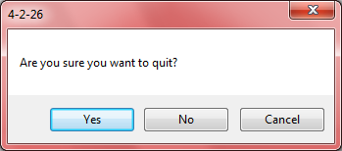
If you click yes then:
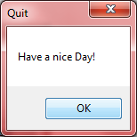
'Programmer: Samantha Naini
'Date: 3/5/2012
'Exercise: 4-2-28 pg. 127
'Program Purpose: To handle a savings account withdrawal. The program should request the
'current balance and the amount of the withdrawal as input and then display the new balance.

Option Strict On
Option Explicit On

Public Class frmWithdrawal

Private Sub btnCompute_Click(ByVal sender As System.Object, ByVal e As System.EventArgs) Handles btnCompute.Click

Dim CurrBal, Withdraw, NewBal As Double

CurrBal = CDbl(txtCurrBal.Text)
Withdraw = CDbl(txtWithdraw.Text)

NewBal = CurrBal - Withdraw

If Withdraw > CurrBal Then

txtNewBal.Text = "" & FormatCurrency(NewBal) & ""
lstStatus.Items.Add("Withdrawal denied.")

ElseIf NewBal < 150 Then
txtNewBal.Text = "" & FormatCurrency(NewBal) & ""
lstStatus.Items.Add("Balance below $150.")

ElseIf NewBal Then

txtNewBal.Text = "" & FormatCurrency(NewBal) & ""
lstStatus.Items.Add("Withdrawal complete.")

End If

End Sub

Private Sub btnClear_Click(ByVal sender As System.Object, ByVal e As System.EventArgs) Handles btnClear.Click
txtCurrBal.Clear()
txtCurrBal.Focus()

txtWithdraw.Clear()
txtNewBal.Clear()
lstStatus.Items.Clear()
End Sub

Private Sub btnEnd_Click(ByVal sender As System.Object, ByVal e As System.EventArgs) Handles btnEnd.Click
Me.Close()
End Sub
End Class

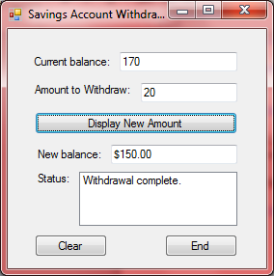←Ex1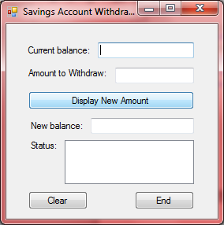←Clear button
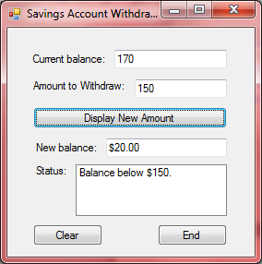←Ex2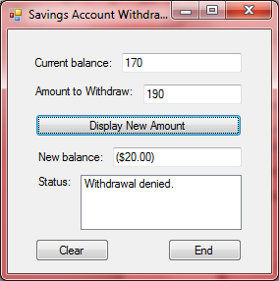←Ex3

'Programmer: Samantha Naini
'Date: 3/5/2012
'Exercise: 4-2-31 pg. 127
'Program Purpose: Write a program that requests as
'input the number of hours a person works in a given week and his hourly wage, then displays his gross pay.

Option Strict On
Option Explicit On

Public Class frmGrossPay

Private Sub btnCompute_Click(ByVal sender As System.Object, ByVal e As System.EventArgs) Handles btnCompute.Click

Dim hours, wage, gross As Double

hours = CDbl(txtHours.Text)
wage = CDbl(txtWage.Text)

If hours > 40 Then
gross = (40 * wage) + (1.5 * wage * (hours - 40))
txtGrossPay.Text = "" & FormatCurrency(gross) & ""

ElseIf hours <= 40 Then

gross = (hours * wage)
txtGrossPay.Text = "" & FormatCurrency(gross) & ""

End If

End Sub

Private Sub btnClear_Click(ByVal sender As System.Object, ByVal e As System.EventArgs) Handles btnClear.Click
txtHours.Clear()
txtHours.Focus()
txtWage.Clear()
txtGrossPay.Clear()
End Sub

Private Sub btnEnd_Click(ByVal sender As System.Object, ByVal e As System.EventArgs) Handles btnEnd.Click
Me.Close()
End Sub
End Class

Ex1) 40 hours or less:
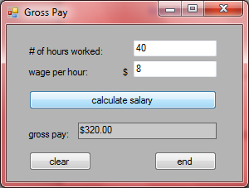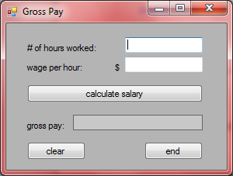←clear button

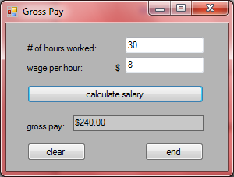

Ex2) More than 40 hours:
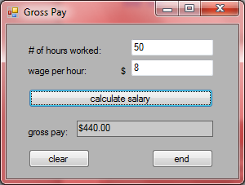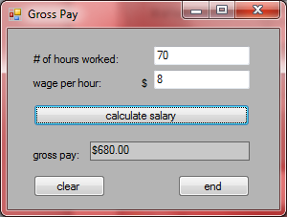
________________________________________________________________________________________
'Programmer: Samantha Naini
'Date: 3/5/2012
'Exercise: 4-2-37, pg.128
'Program Purpose: To show and hide the name of the programming language by clicking a button.

Option Strict On
Option Explicit On

Public Class frmHideAndSeek

Private Sub btnDisplay_Click(ByVal sender As System.Object, ByVal e As System.EventArgs) Handles btnDisplay.Click

If lblLanguage.Visible Then
lblLanguage.Visible = False
btnDisplay.Text = "Show Name of Language"

Else
lblLanguage.Visible = True
btnDisplay.Text = "Hide Name of Language"

End If

End Sub
End Class
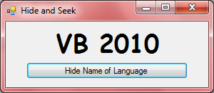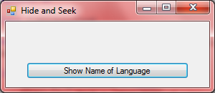

'Programmer: Samantha Naini
'Date: 3/8/2012
'Exercise: 4-2-38 pg.128
'Program Purpose: Create a program displaying the tax on an income depending on the amount the person makes.

Option Strict On
Option Explicit On

Public Class frmIncomeTax

Private Sub btnCompute_Click(ByVal sender As System.Object, ByVal e As System.EventArgs) Handles btnCompute.Click

Dim Income, Tax As Double
Dim Output As String

Income = CDbl(txtIncome.Text)
Output = CStr(txtOutput.Text)

If Income <= 20000 Then

Tax = 0.02 * Income
txtOutput.Text = "" & FormatCurrency(Tax) & ""

ElseIf Income <= 50000 Then

Tax = 400 + 0.025 * (Income - 20000)
txtOutput.Text = "" & FormatCurrency(Tax) & ""
Else

Tax = 1150 + 0.025 * (Income - 50000)
txtOutput.Text = "" & FormatCurrency(Tax) & ""

End If

End Sub

Private Sub btnClear_Click(ByVal sender As System.Object, ByVal e As System.EventArgs) Handles btnClear.Click
txtIncome.Clear()
txtIncome.Focus()
txtOutput.Clear()
End Sub

Private Sub btnEnd_Click(ByVal sender As System.Object, ByVal e As System.EventArgs) Handles btnEnd.Click
Me.Close()
End Sub

End Class
